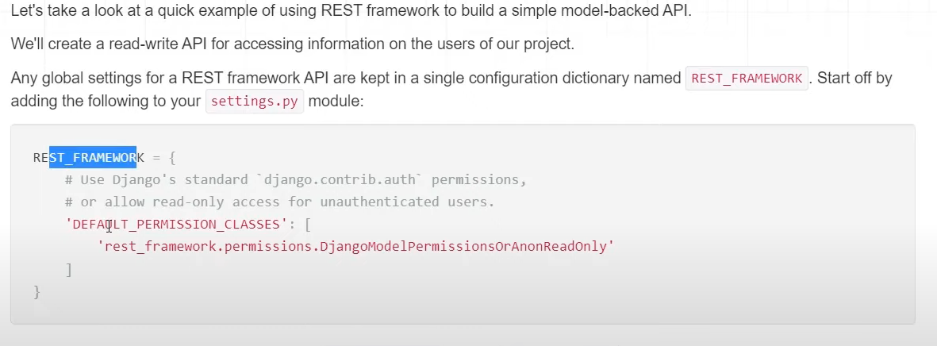

If we only want to read data from software not write then we will make use of in settings